**NA project spreading model**

Modified SIR model:

* S = susceptible,
* I = infected (knowledge of rumour and further tells neighbours),
* R = removed (knows the rumour but will no longer attempt to tell their neighbours)

Triggering: Classical spreading:

* For any infected node, the probability of telling the information to any neighbour is determined by parameter β.
* Use starting node s

Limited infection chances:

* Any infected node transitions into state R after α time steps of being affected
* Spreading stops when all nodes are either in state I or R

Parameters

* β, probability that you will tell your neighbor
* α, timesteps before node become non-contagious

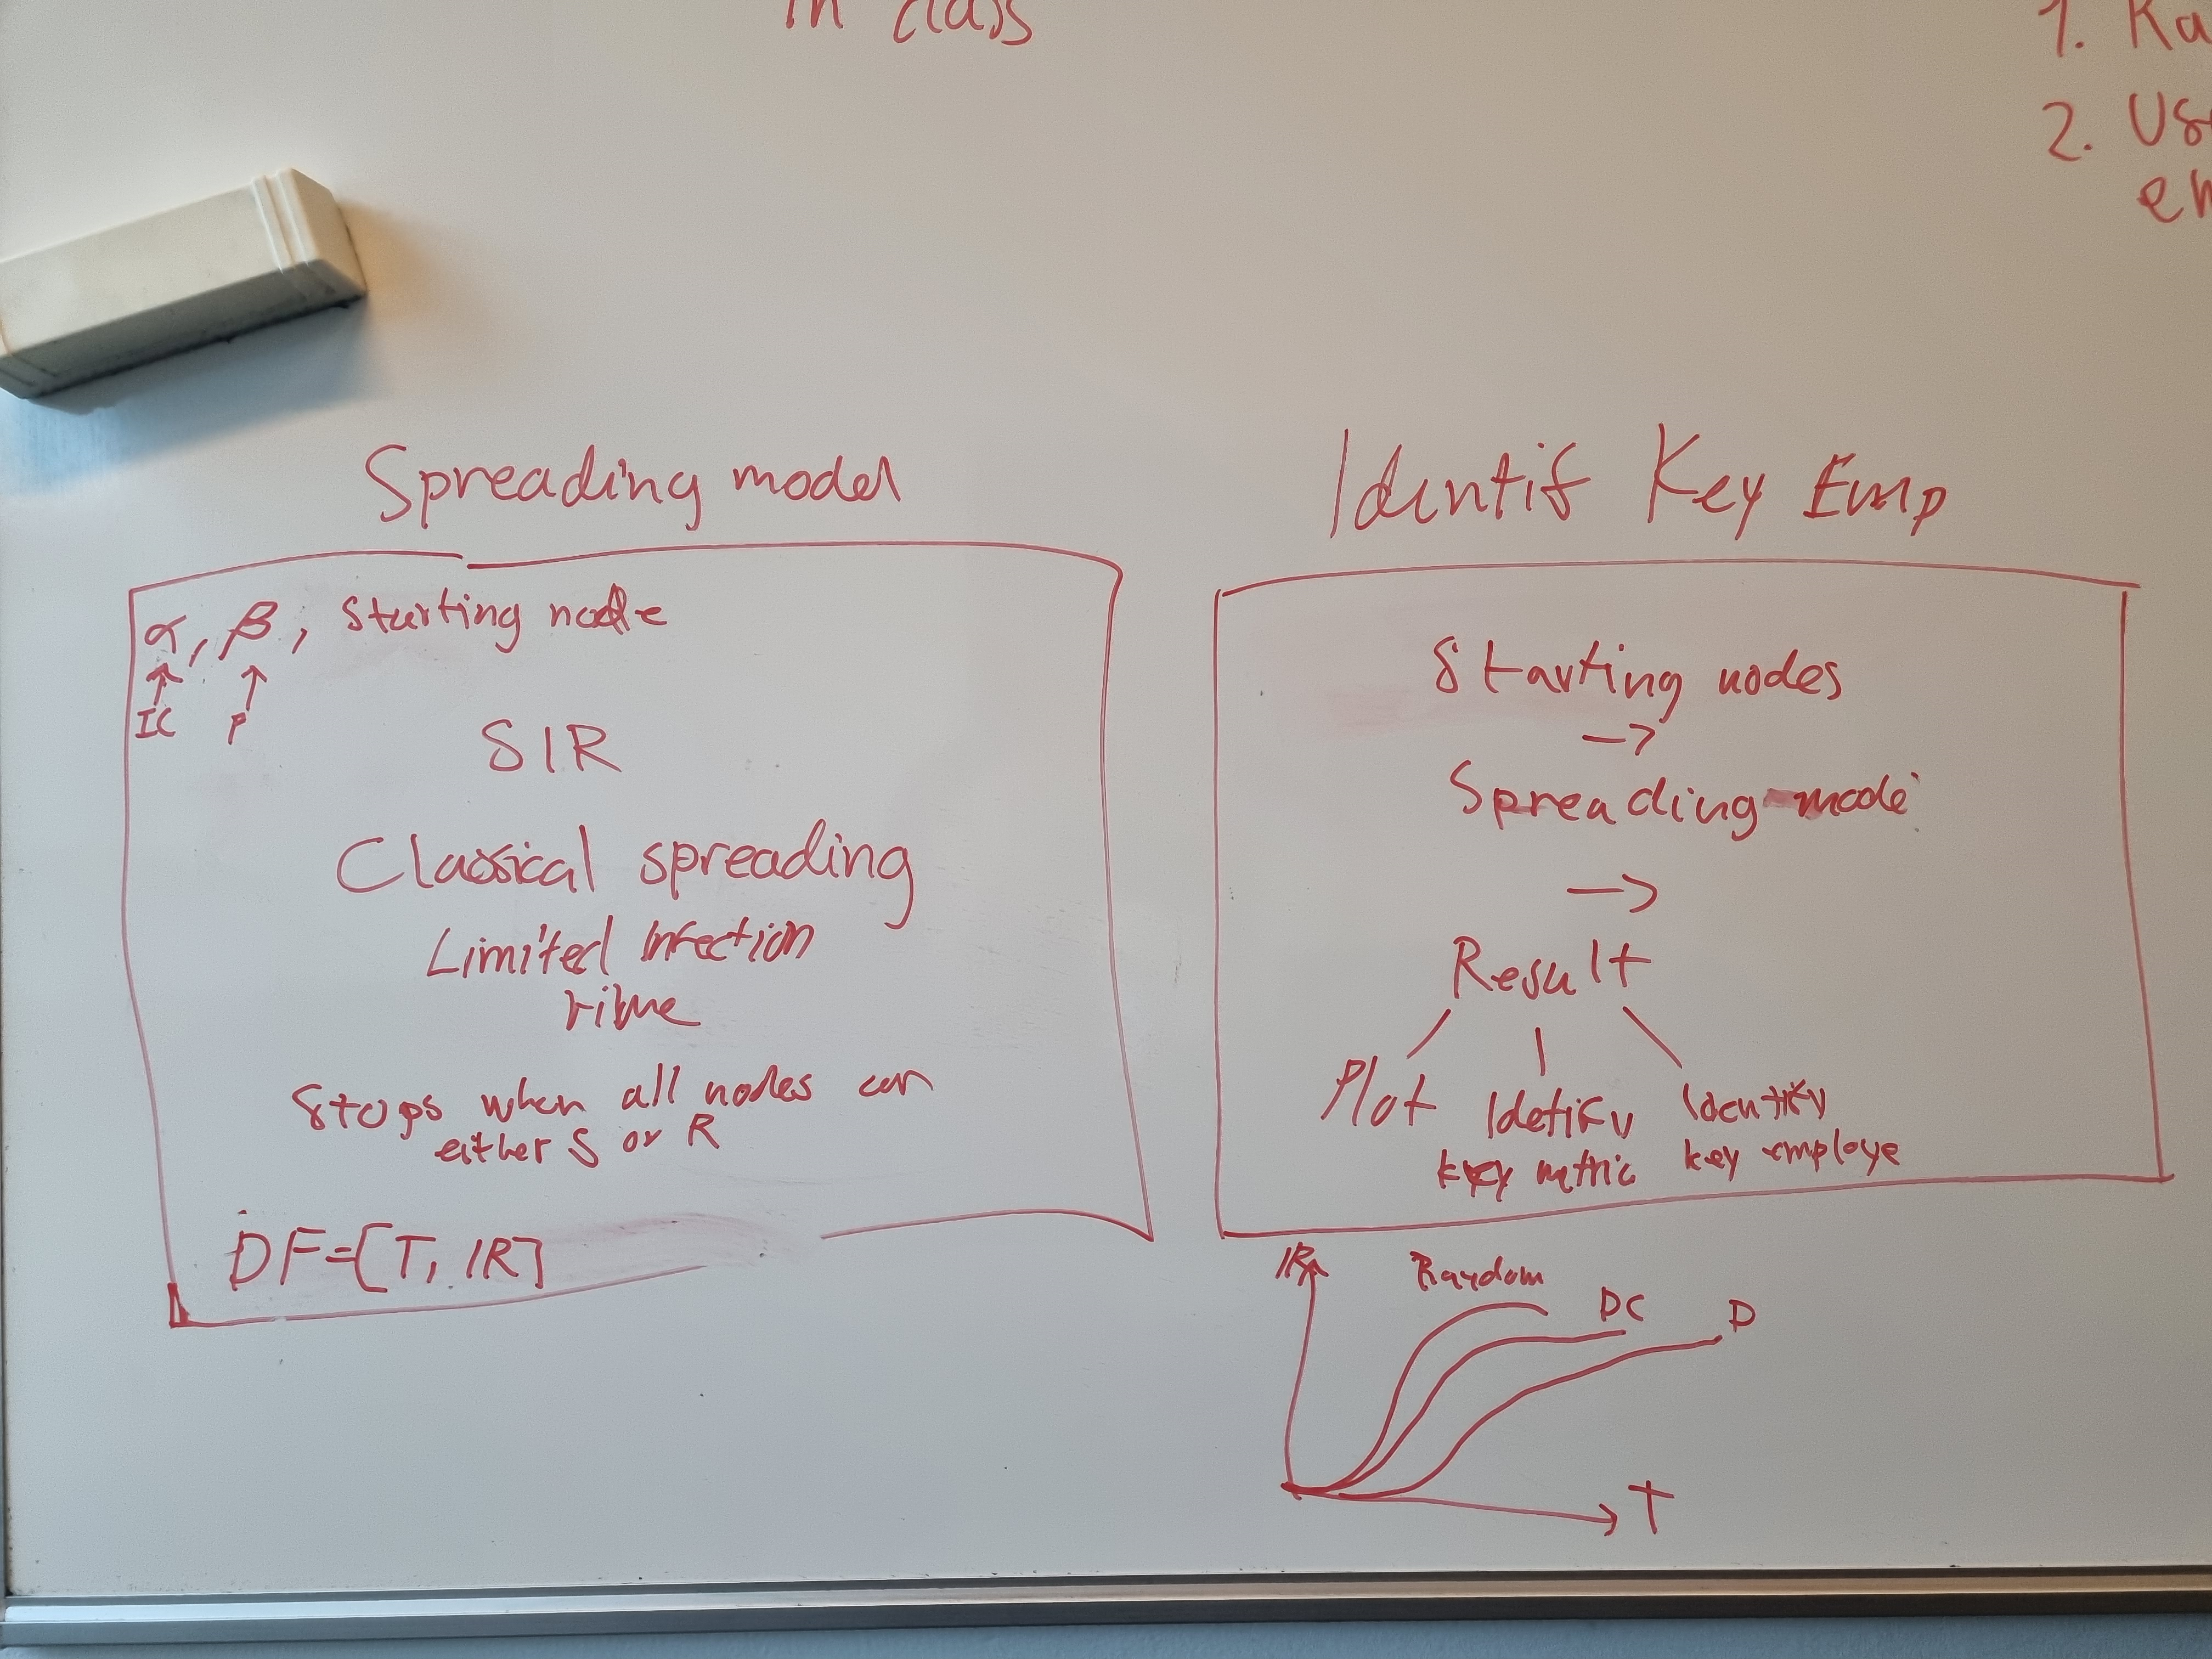

**Identify key employees**

We want to determine the ‘best’ starting nodes if you want to spread a rumor in the company.

We look at how the disease spread for different starting nodes that are chosen randomly or according to a given metrics.

Code: starting node -> spreading model -> results

* Plot the result for the different metrics
* Identify key metrics (e.g., high degree, high betweenness centrality)
* Identify key employees